## 

Dr.R.Anand

KCG College of Technology

**V2V Courier Service**

Web development is the work involved in developing a website for the Internet (World Wide Web) or an intranet (a private network). Web development can range from developing a simple single static page of plain text to complex web-based internet applications (web apps), electronic businesses, and social network services. A more comprehensive list of tasks to which web development commonly refers, may include web engineering, web design, web content development, client liaison, client-side/server-side scripting, web server and network security configuration, and e-commerce development.

For larger organizations and businesses, web development teams can consist of hundreds of people (web developers) and follow standard methods like agile methodologies while developing websites. Smaller organizations may only require a single permanent or contracting developer, or secondary assignment to related job positions such as a graphic designer or information systems technician. Web development may be a collaborative effort between departments rather than the domain of a designated department. There are three kinds of web developer specialization: front-end developer, back-end developer, and full-stack developer. Front-end developers responsible for behavior and visuals that run in the user browser, while back-end developers deal with the servers.

Courier Management System is software for the cargo offices where the customer can approach the office and book an article or good. The manager/clerk can use this software to enter the details of the customer and goods along with the source and destination points. The details of loading the goods into the physical transport system are also recorded by the system. The system has GUI for the users to manage not only daily transactions but also to keep the historical data in the database for future reference.

The other user of the system is administrator who can manage the vehicles information as well as employees’ information. The Admin can also create new branch based on based on branch requests and can decide the route for the cargo to take on a particular day so that delivery

happens at the customer’s nearest point. Also it provides the management reports like monthly goods bookings, loadings, deliveries, and receiver’s particulars.

## OBJECTIVE

This project deals with the ‘Courier management’. The system is used for daily activities such as booking, loading, delivery, status check, and managing branches. It is very difficult to do this process manually. Hence it is recommended to computerize the process by developing the relative software as the world is turning into information and technology; computerization becomes necessity in all walks of life. Keeping record of parcels in a courier service company and their delivery information is carried out manually. This litters the office with much paper documents. Most often records are misplaced and when a client comes to collect his parcel, the client have to spend some hours waiting for confirmation of the parcel.

SYSTEM USE CASE DIAGRAM:

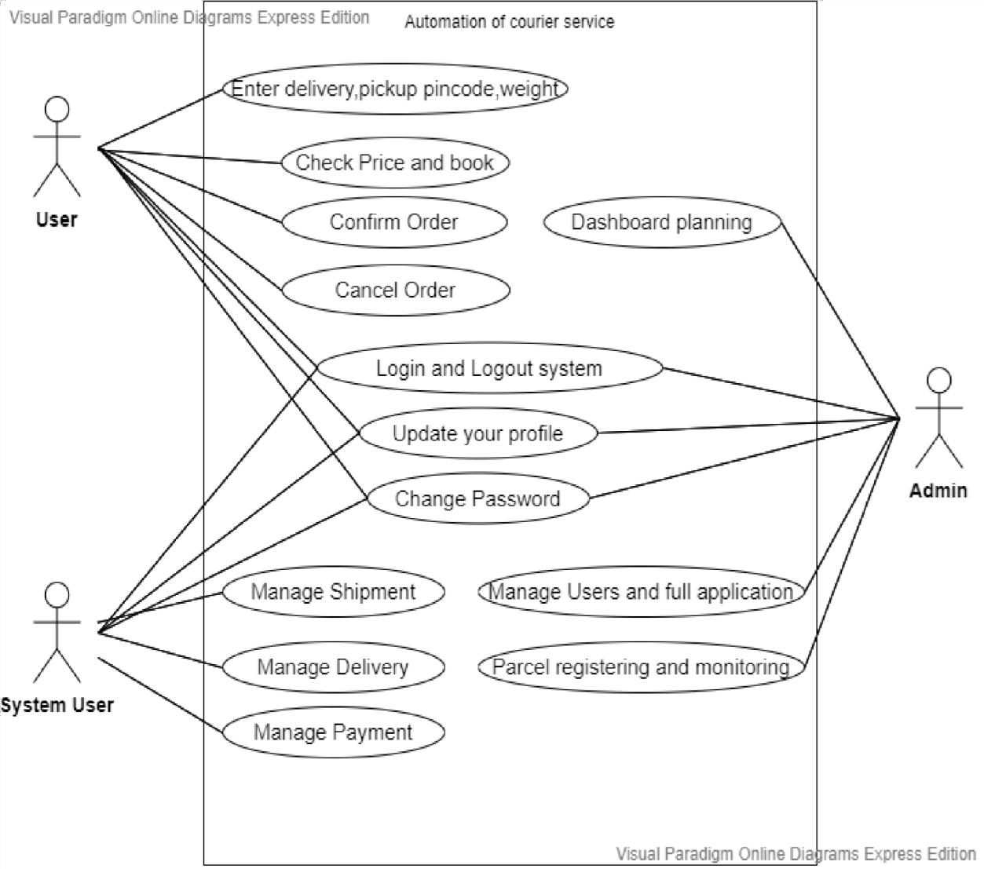

## ACTOR INVOLVED:

* + - * User
      * Admin
      * System User

## User:

After login to the system user will book the order by entering the pickup and delivery pin code, weight and type of the package.

## Admin:

Admin is responsible for managing users and full application, parcel registering and monitoring, dashboard planning.

## System User:

System User is responsible for managing shipment, payment and delivery.

## SEQUENCE DIAGRAM:

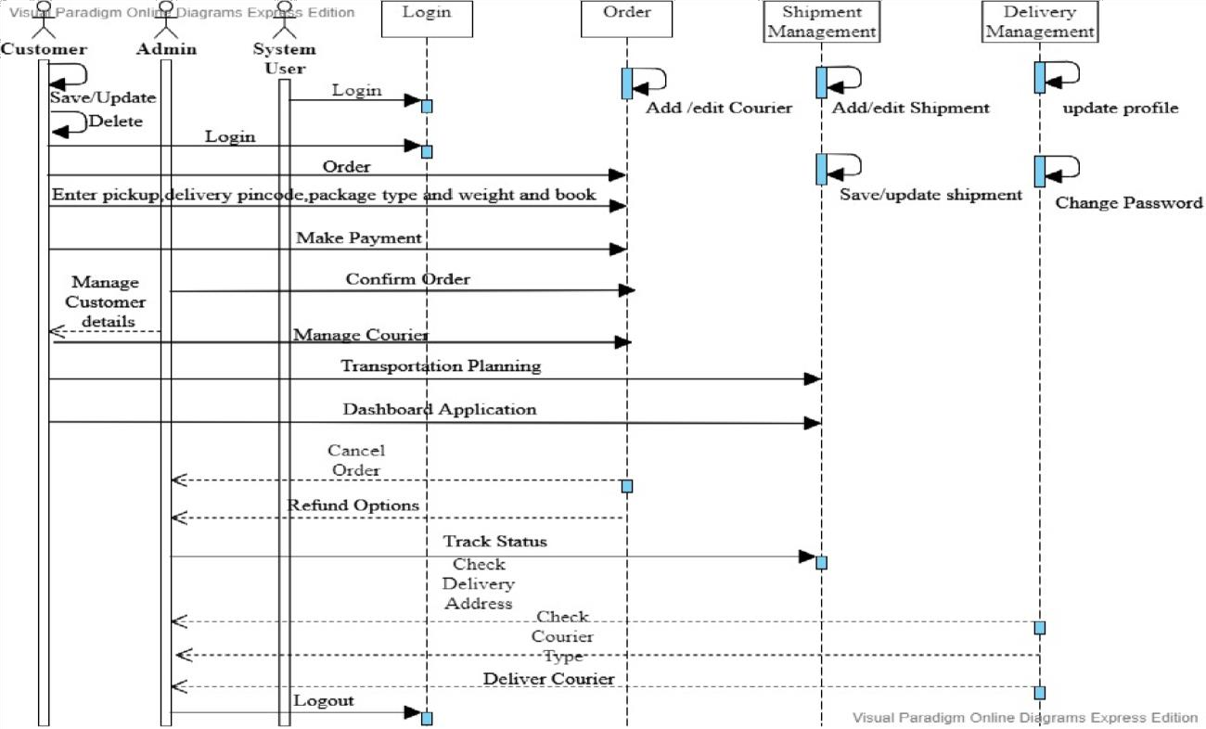

* + - * Sequence diagram simply depicts interaction between objects in a sequential order. It shows how operations are carried out.
      * The operations of the admin include managing users, managing full application, parcel registering, parcel monitoring and dashboard planning.
      * System user includes the operations like managing customer details, managing shipment, and managing delivery.

## CLASS DIAGRAM:

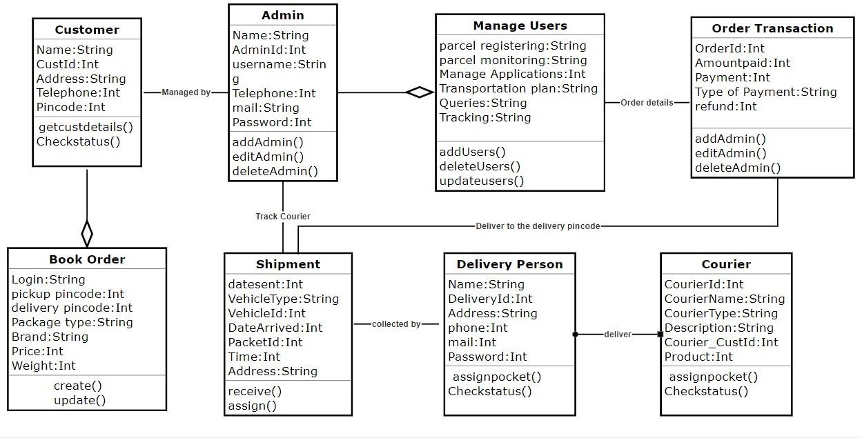

A class diagram is a type of static structure diagram that describes the structure of the system by showing the system’s classes their attributes, operations and the relationships among objects.

## DEPLOYMENT DIAGRAM:

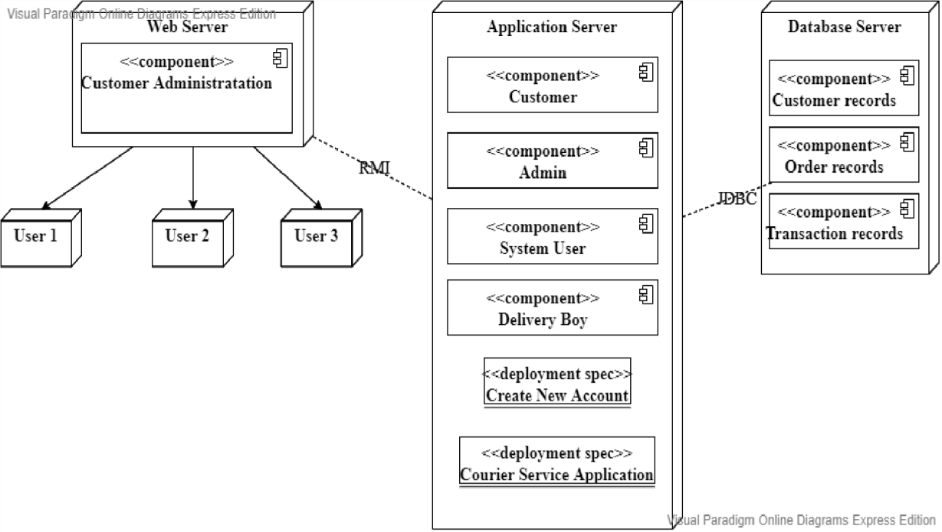

A deployment diagram shows the execution architecture of the system, including nodes such as hardware or software execution environments and the middleware connecting them. Deployment diagram are typically used to visualize the physical hardware and software of a system.

Deployment diagram can be used for,

* + - * Modelling the network topology of a system.
      * Modelling distributed systems and networks.
      * Forward and reverse engineering process.

A deployment diagram consists of the following notations:

* + - * A node
      * A component
      * An artifact
      * An interface

## ACTIVITY DIAGRAM:

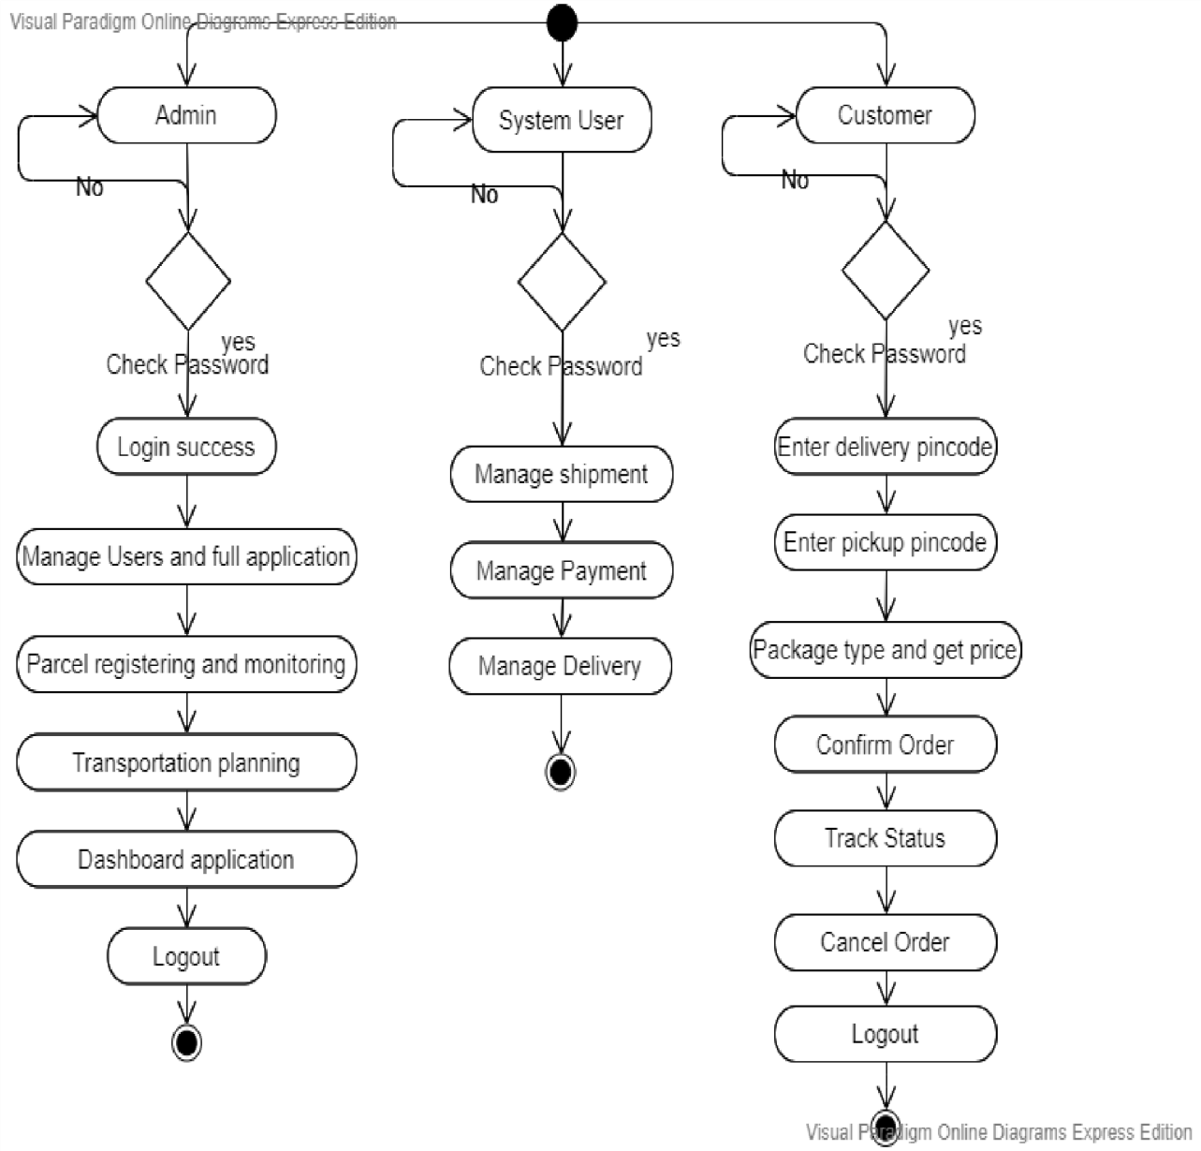

Activity diagram is used to describe the important aspects of the system. It is basically a flowchart to represent the flow from one activity to another activity. The control flow is drawn from one operation to another. This flow can be sequential, concurrent or branched.

Activity diagram uses the following notations.

* + - * Initial states
      * Final states
      * Action box
      * Decision box

## DATA FLOW DESIGN:

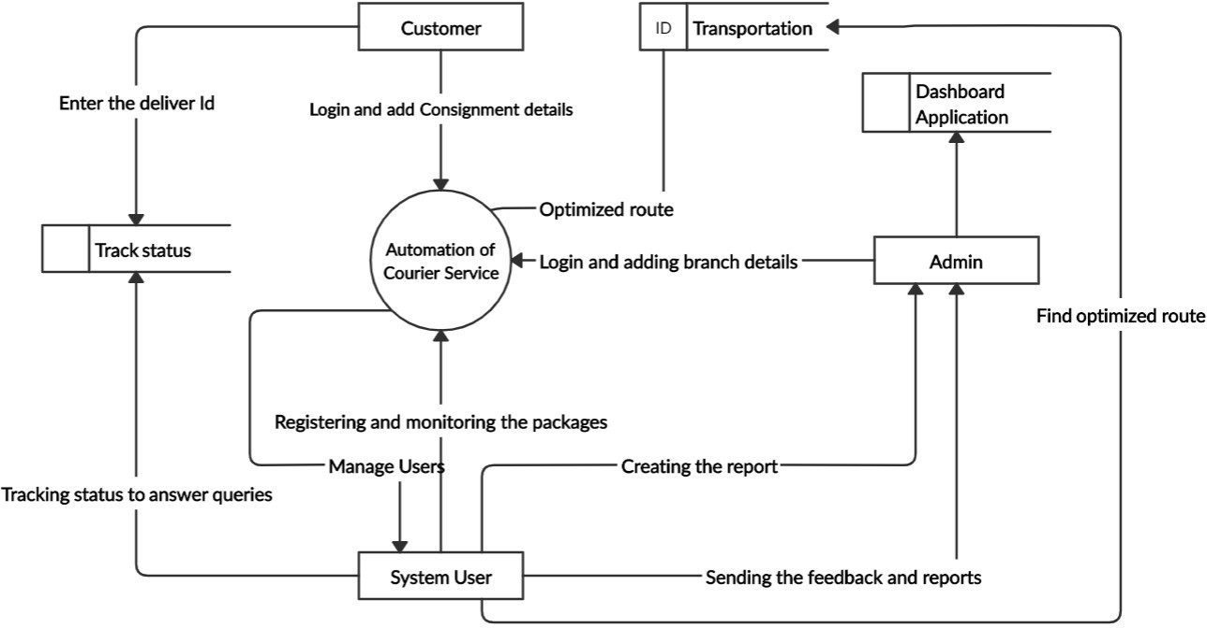

A data flow diagram is a way of representing a flow of data of a process or a system. The DFD also provides information about the outputs and inputs of each entity and the process itself. The main function of the system is automation of courier service.

## Parcel Registering and monitoring Module:

This module is used by the customer facing offices work in the branch offices to accept the parcels and payments from user’s .The customer facing offices should be able to monitor current status of the parcels to answer the queries from the customers.

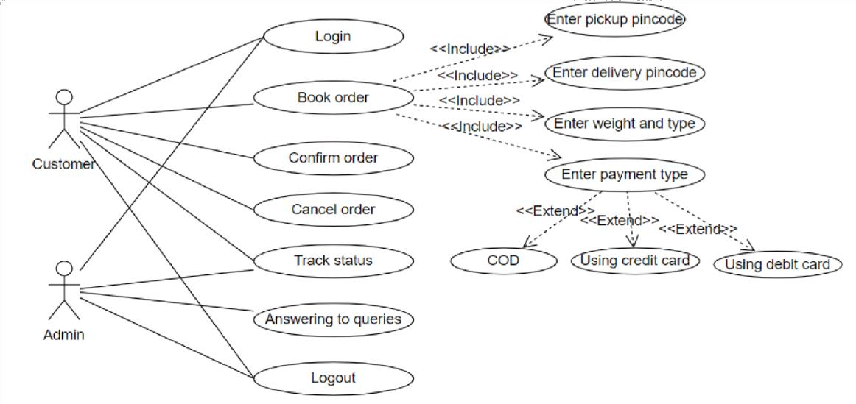

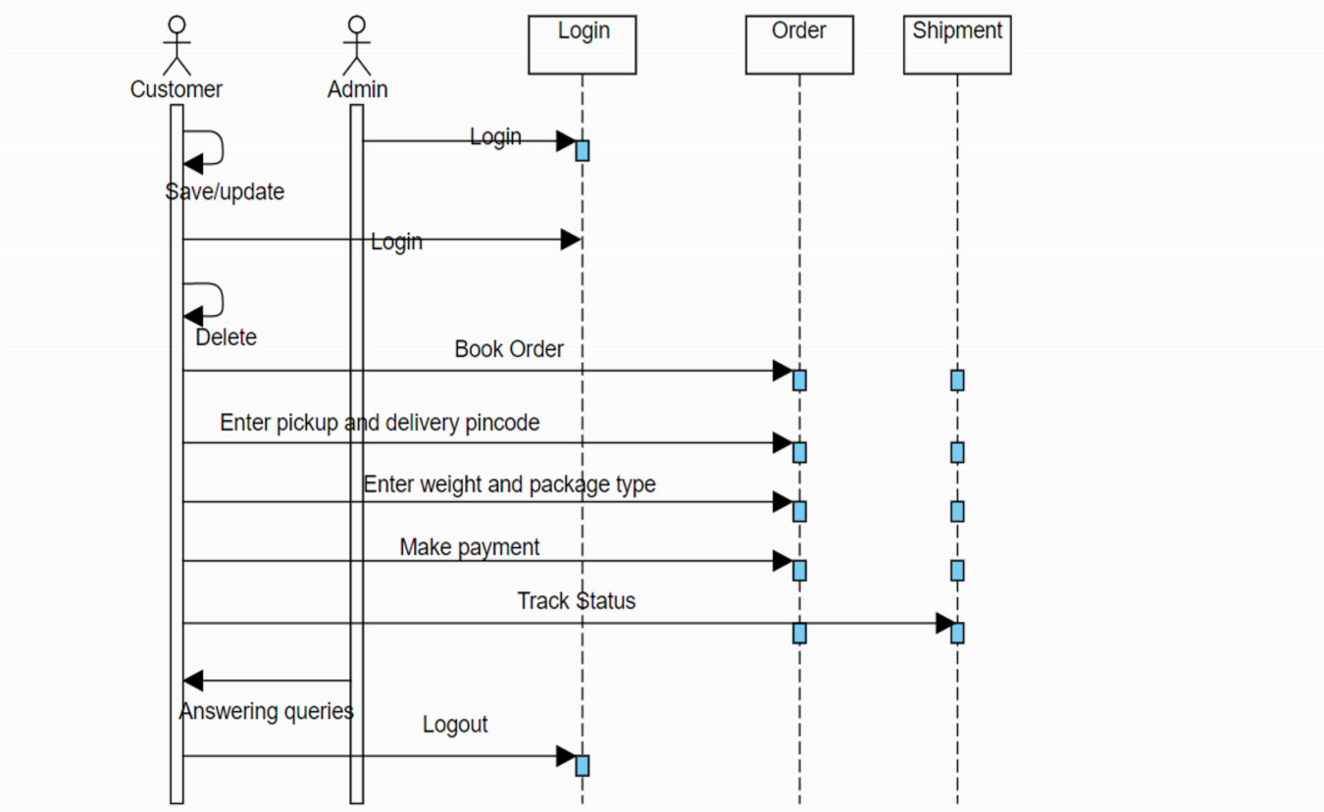

## Transportation Planning Module:

This module is used by the back office to manage transportation vehicles and their routes. This module should plan the vehicle routes to optimize the cost, while maintaining the SLAs (of the parcel types).

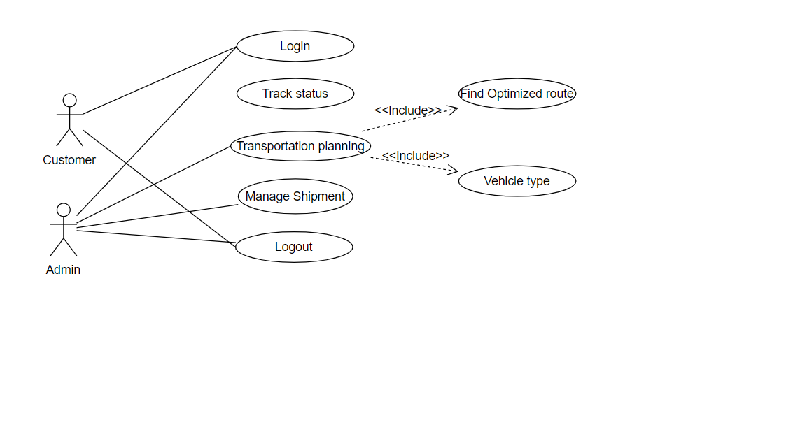

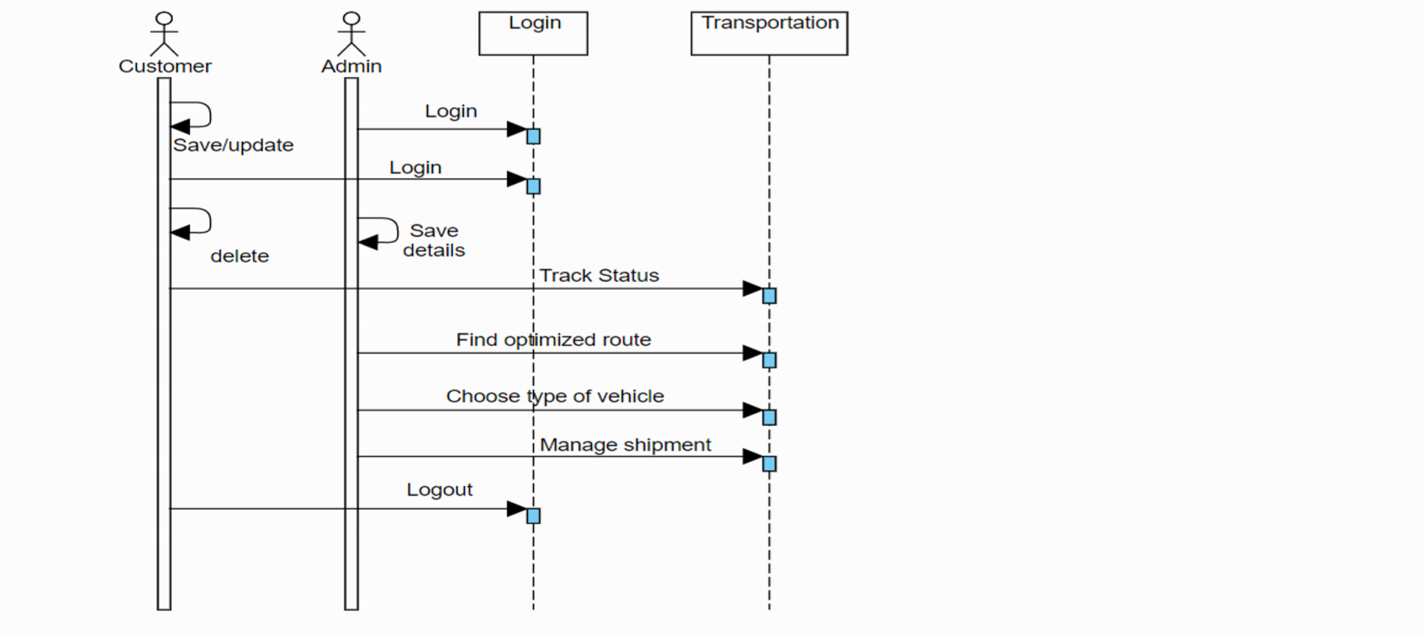

## Parcel Location Data Capture Module:

This module should capture entry and exit of all parcels to branch offices, parcel distribution centres, transportation vehicles and the final destination. This module should also capture the location of each parcel transport vehicle in every five minutes. This information is used by the other modules to track the parcel location, estimate the delivery time, optimize the delivery routes, etc.

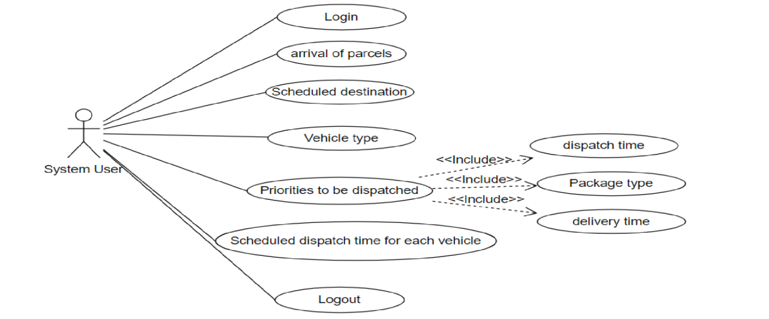

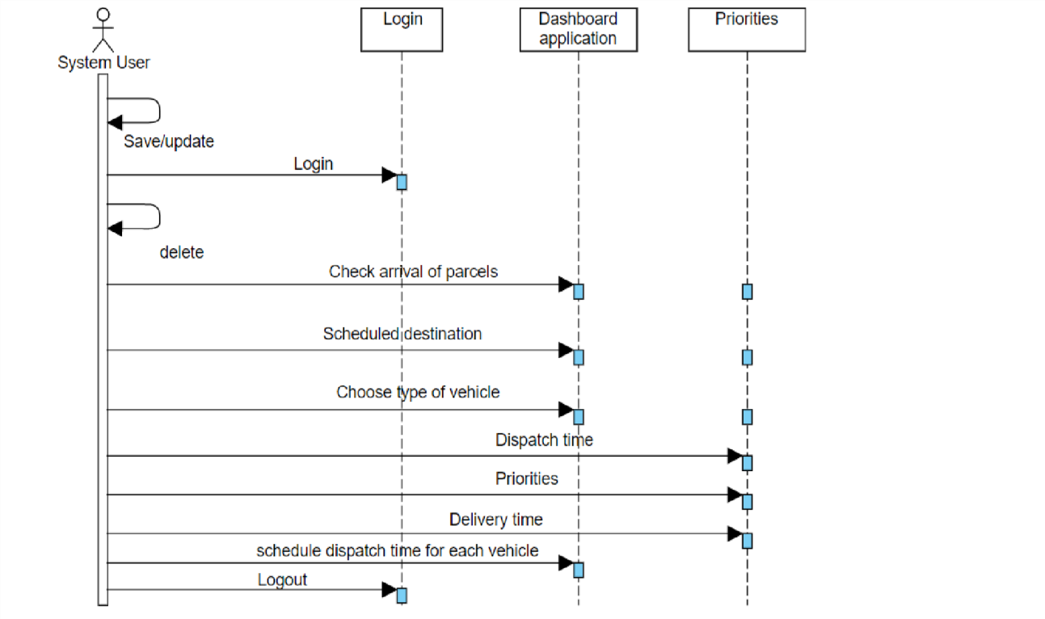

## CONCLUSION:

There is always a scope of betterment and this system is not against this perception. At present the software system satisfies most of the functions of a very general Courier management system.

* + - The courier services are automated as hand written documentation is minimized to a bare minimum the software is fully implemented.
    - The data can be easily backed up onto a reliable media so that no or minimal data loss is there in case of system crush.
    - Unauthorized access to the data is nearly eliminated by providing password authentication system.
    - This system has made us require a professional outlook towards problem statement and solving it to the best and maximum.